Below is a simple, step-by-step flow of the process. Think of it as following a treasure map where each step leads you closer to the treasure (your clean data)! Here’s how you do it:

* **Step 1: Open Excel**
  + Launch Excel on your computer.
  + Click on the **Data** tab at the top.
* **Step 2: Find Your Data File**
  + Click on **Sources** and then choose **Excel Workbook**.
  + Look for and select your Excel file where your data is stored.
* **Step 3: Start Transforming Your Data**
  + Click on **Transform** to begin working on the data.
  + When you transform, filter the data so that only the rows for **our trucks** are shown.
* **Step 4: Work in the Power Query Editor**
  + Once you click **Transform**, the Power Query Editor opens.
  + You can find your source file here below

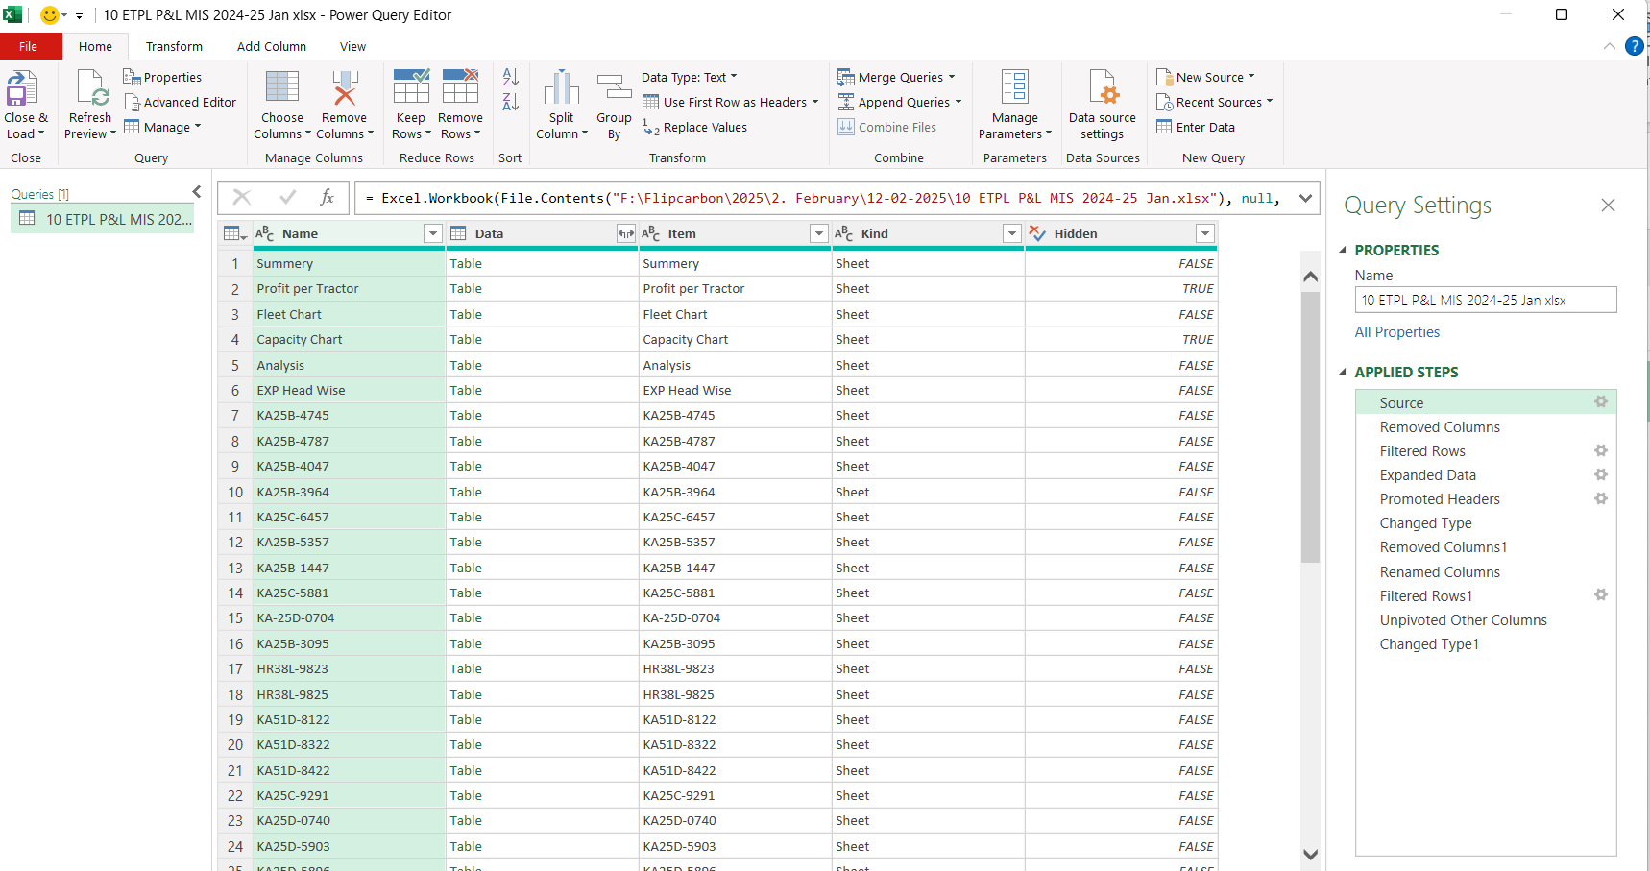

* + We do not need all the columns here hence we can simply remove them

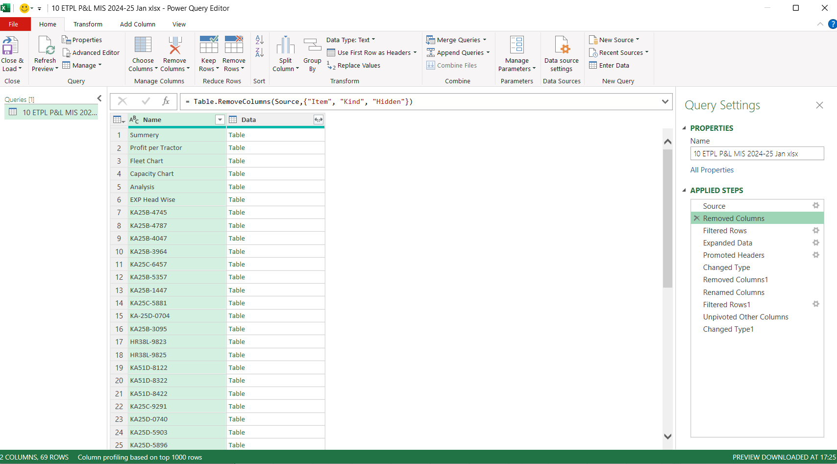

* + Then we will get the data pages in the excel file and the table of meta data associated
  + We need to filter down only our truck pages, if done properly we would have 39 options filtered
  + 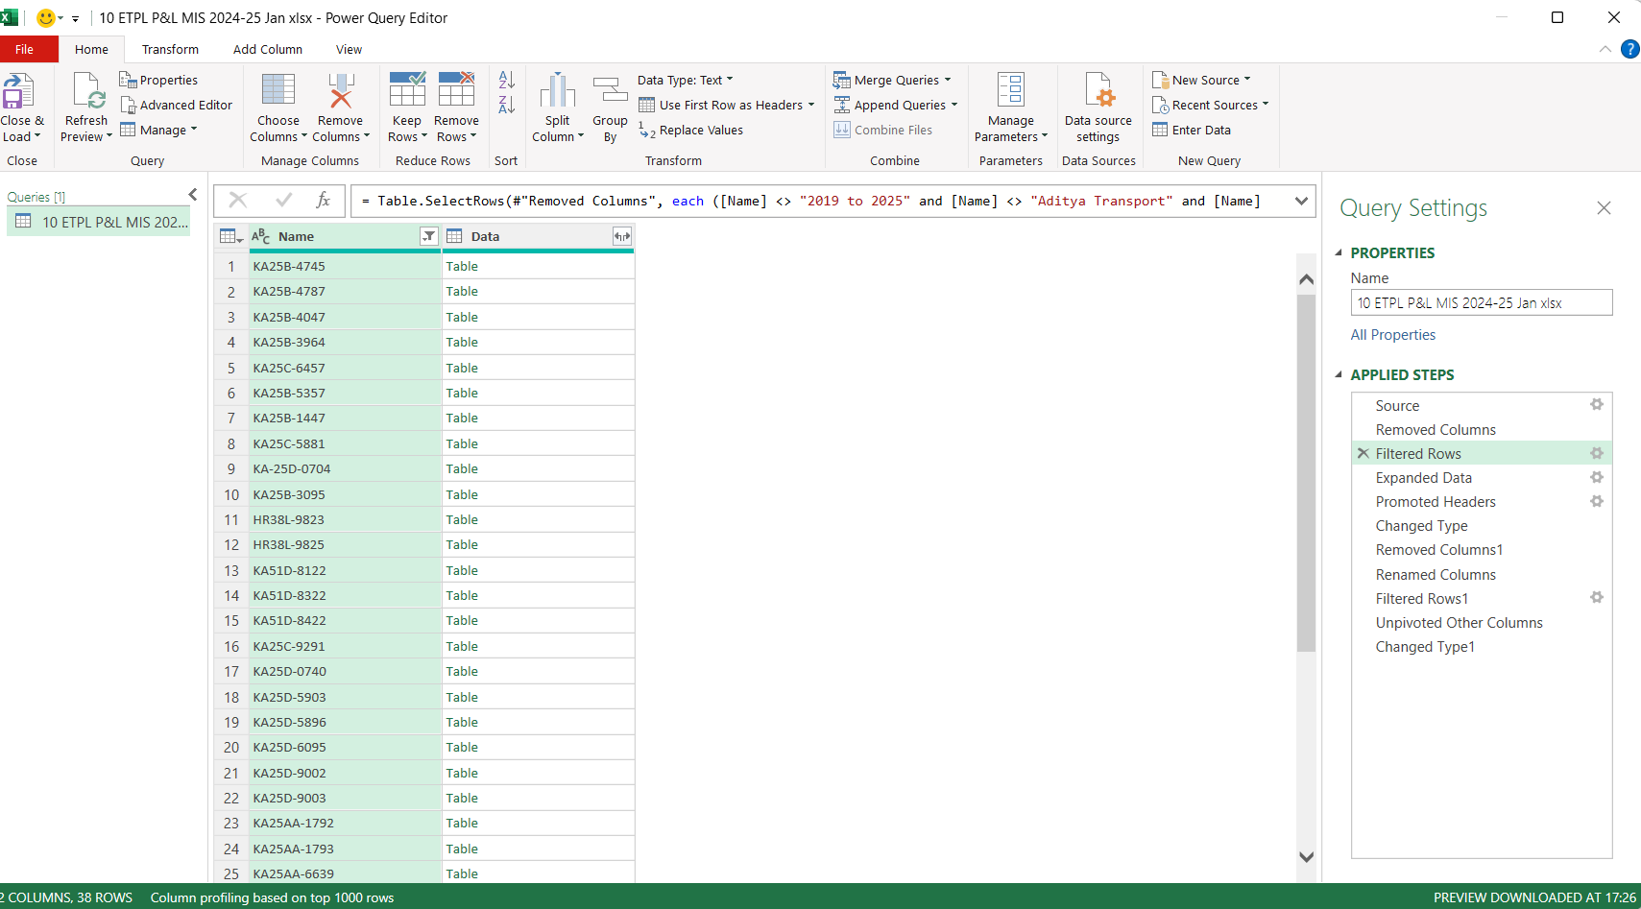Once you have ensured that there are only the selected pages for trucks click on the expand button available to get all the columns in all 39 pages
  + 
  + You would have an expanded data field like this
  + 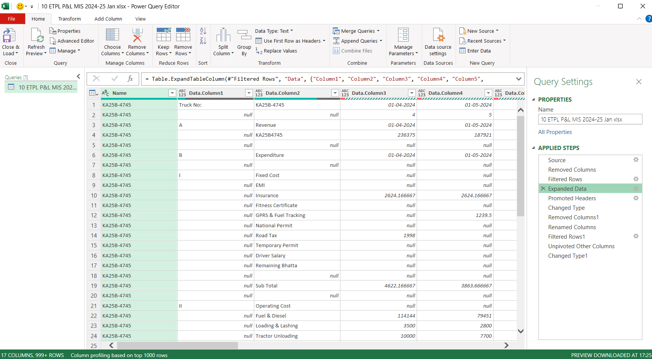
  + In the editor, use the option **"Use the first row as headers"** to make the first row the labels for your columns. This step is to protect the dates as we remove all the unnecessary rows in the following steps, if done properly you will have dates as rows as depicted in the picture below
  + 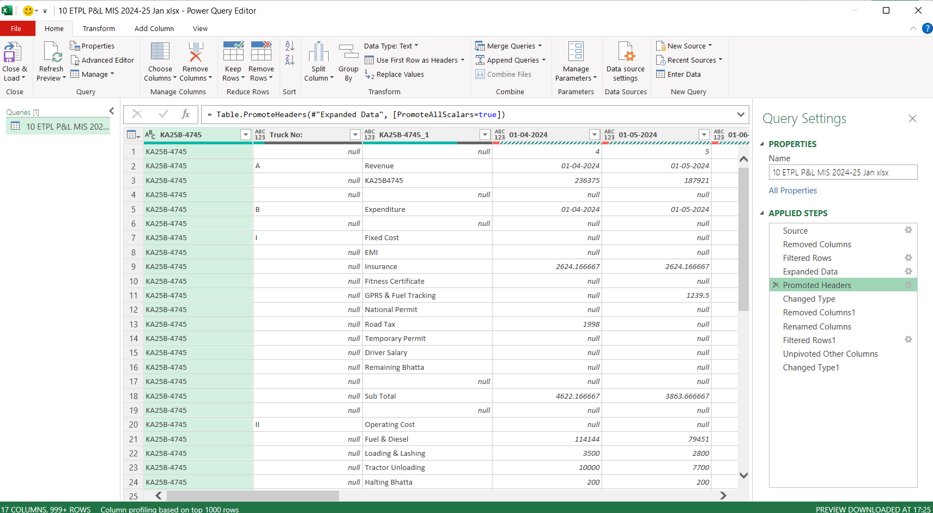
* **Step 5: Clean Up Your Data**
  + **Remove unnecessary columns:** Delete columns like the **Total** column, the last column, or any others that you do not need.
  + 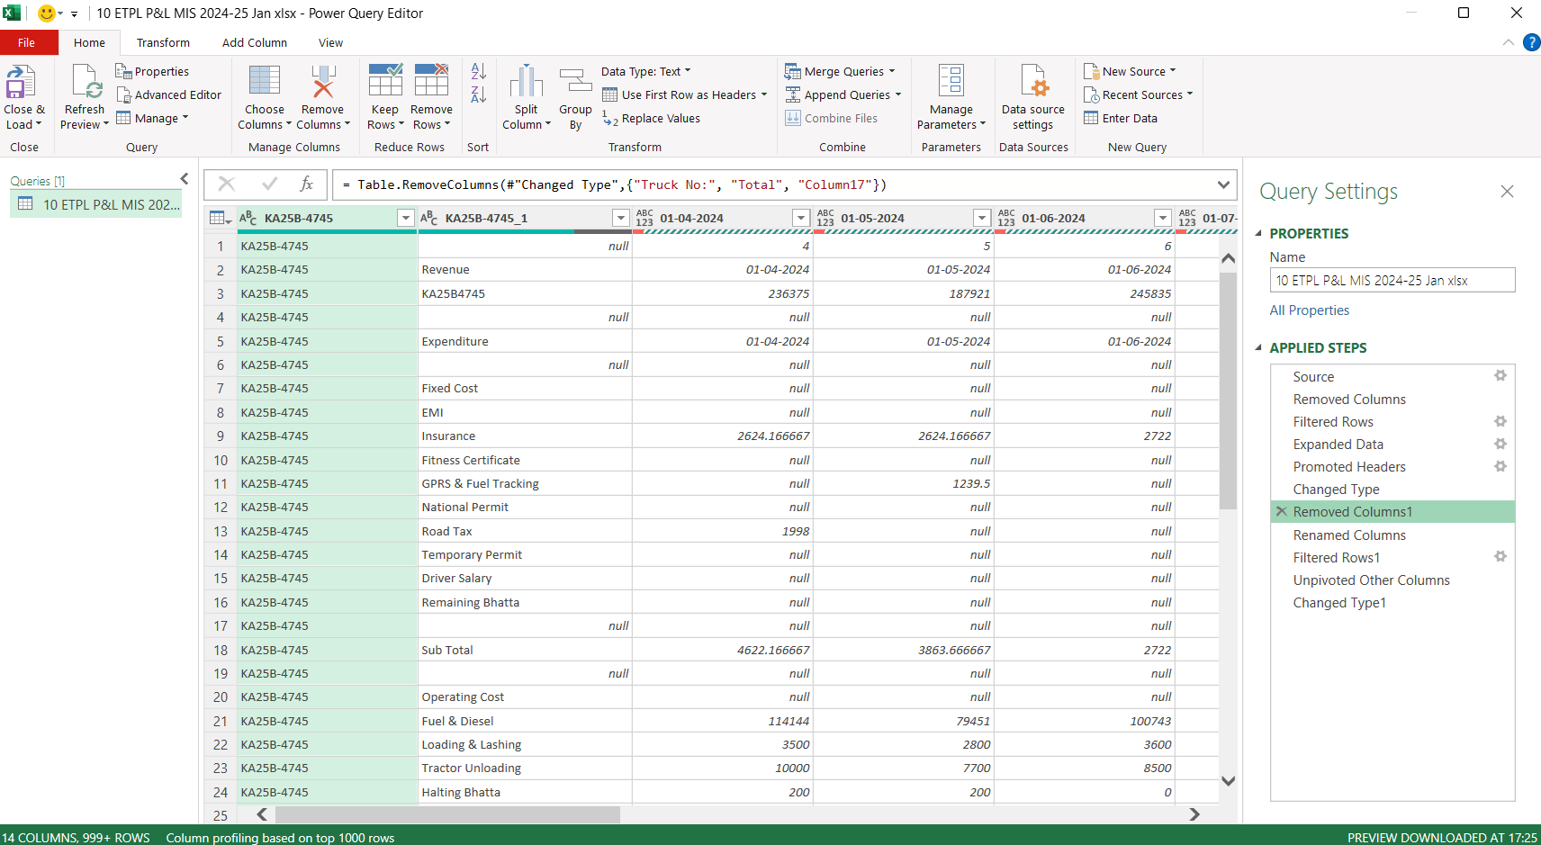After this step is complete you need to rename the columns as show below or else it will interfere with the data model, and renaming in this manner would make it easier for you as well to clean the data further down the line
  + 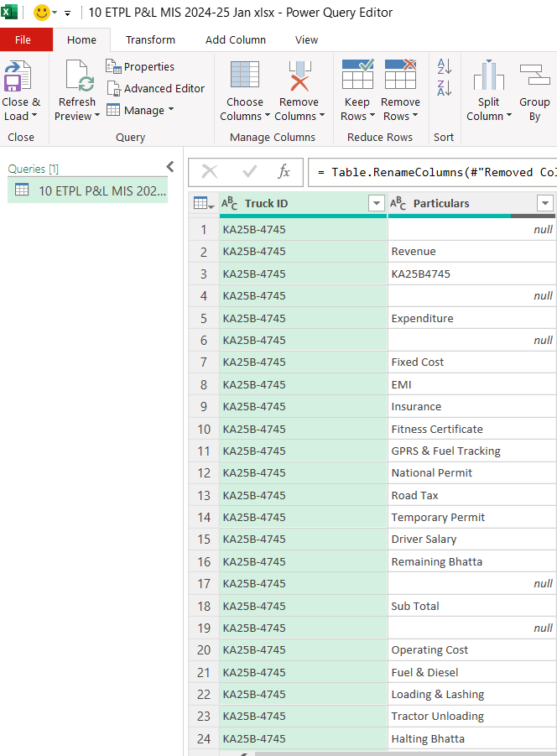
  + Click on the drop down menu and click on load more

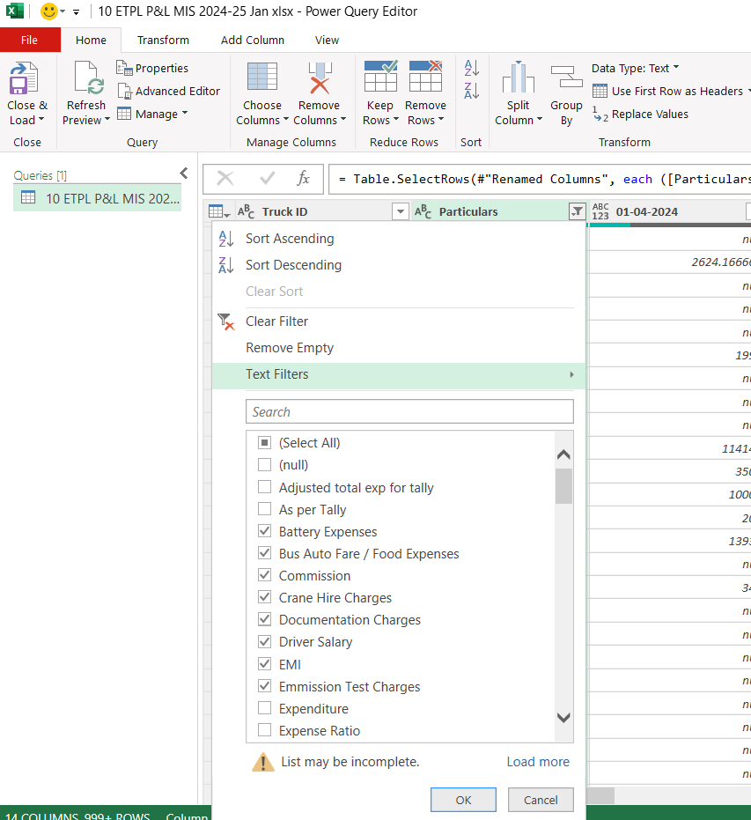

* + **Filter expense items:** In the remaining columns, deselect any line items that are not related to expense items. If done correctly there will be 32 line items like this for each truck
  + 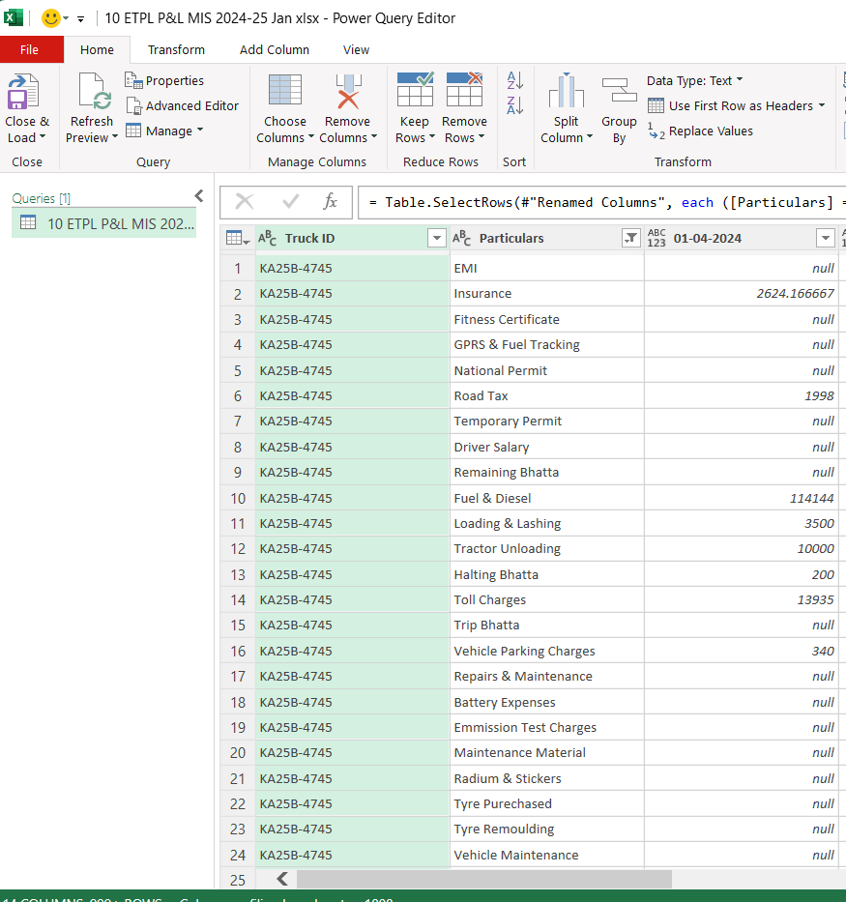
* After this you need to unpivot the remaining columns to get a structured data format to be shared in the google sheets

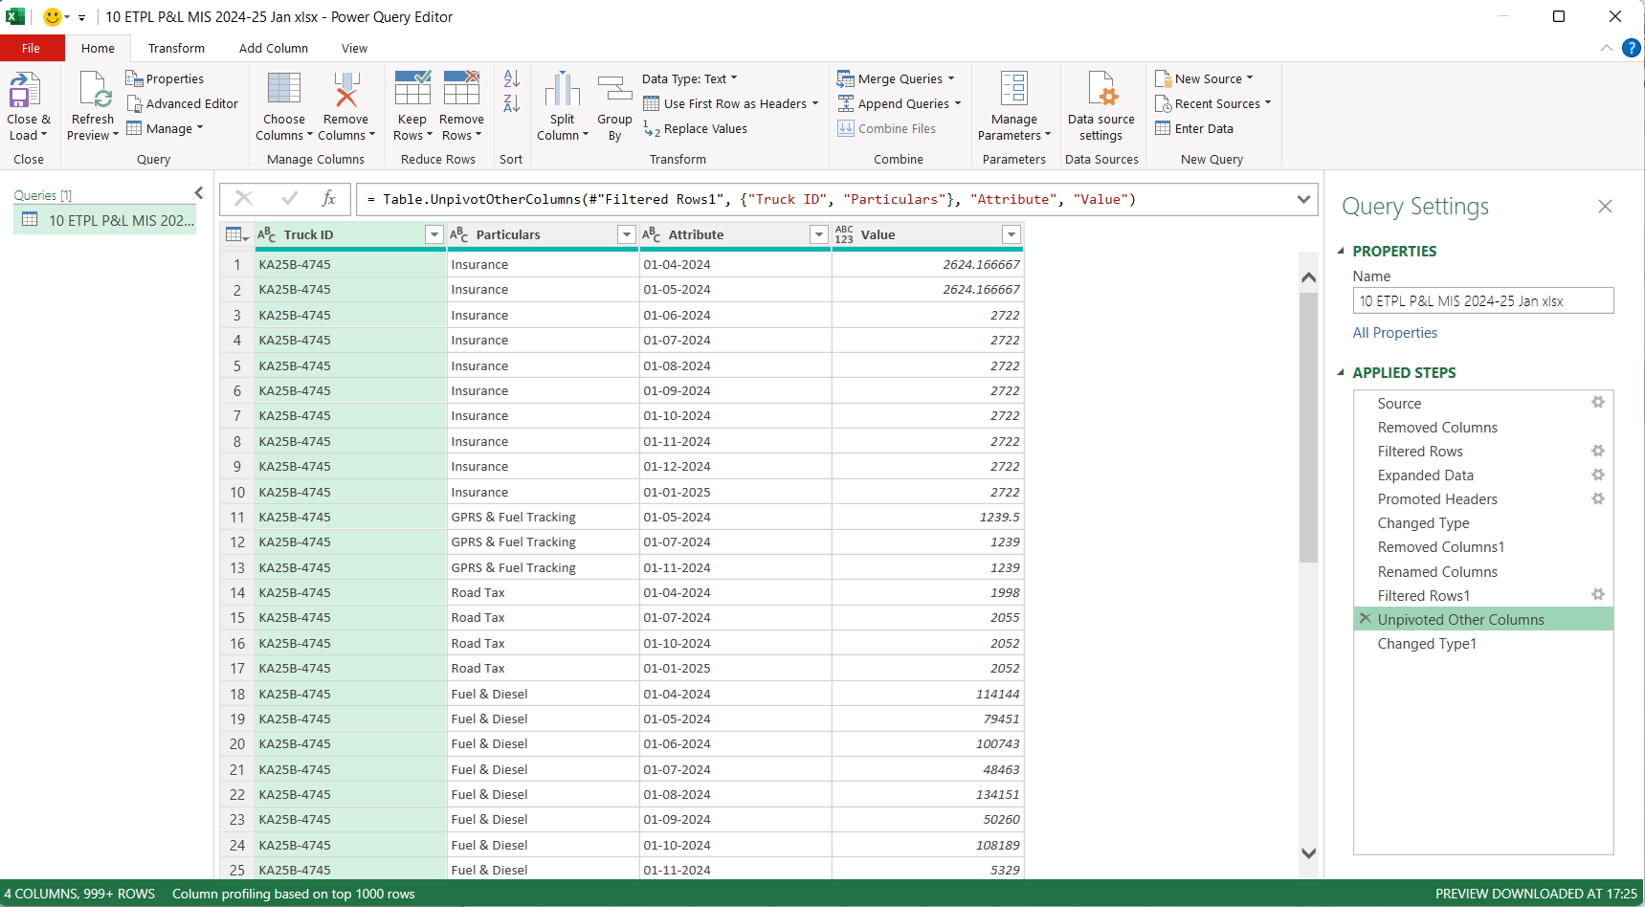After this we need to change the data type to date and decimal number respectively like this



* **Step 6: Load the Clean Data**
  + Click on **Close and Apply**.
  + Your cleaned-up data will now be loaded into a new Excel sheet.
* **Step 7: Update for the Next Month**
  + When a new month starts, update your data source:
    - Go back to the **Source** step in Power Query.
    - Change the file to the new data file as needed.

Process Flow

